Where is FBM KLCI heading?

Kuala Lumpur Composite Index (KLCI) has been trading lower over the past few weeks, breaking through the psychological support level of 1400 on the 8th of June to hit a 52-week low. Several global issues including the post pandemic impacts, the escalating hostilities between Russia and Ukraine, and over-stimulus in US led to a higher inflation and caused the US Federal Reserve to increase an interest rate are among the main factors to be blamed by the financial experts on this underperformance. They added that supply constraints and rising commodity prices had a negative impact which bring a tantrum on the financial markets all over the world. But major indices in the US, Japan, and Singapore have all exhibited some gained and touched 52 weeks high this month while the KLCI has fallen by 7.15% over that time. Furthermore, the value of the Malaysian Ringgit (MYR) has fallen by 4.92% since January against the US Dollar (USD). These elements, together with the underwhelming stock market results and the depreciating currency, have fueled criticism of Prime Minister Datuk Seri Anwar Ibrahim and his government. The current situation has turned into a terrifying nightmare for the Prime Minister since they were relentlessly attacked the previous government's handling of the stock market and the strength of the Malaysian Ringgit relative to the US Dollar when they were in the opposition. The irony is now painfully obvious as they come under great scrutiny for fell short of their own words and standards, leading the public to doubt their leadership and capability to deal with the current economic issues.

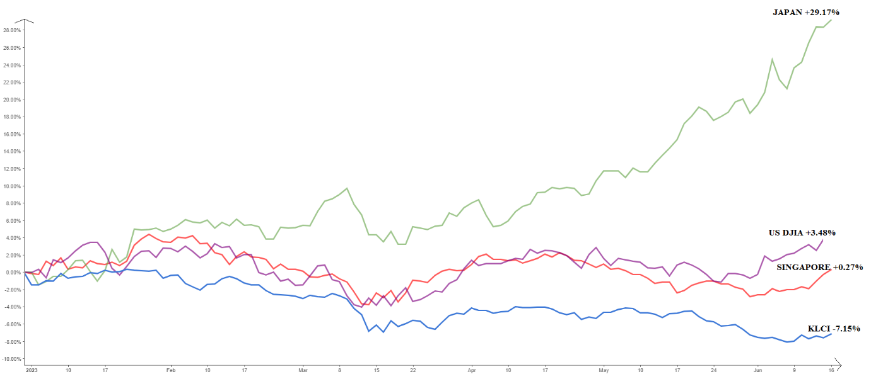
Figure 1: Performance of selected indexes in 2023
Source: Author’s collection.

First and foremost, it is crucial for current and future leaders to break free from the practice of associating themselves with a government's success during favourable stock market performance or a strong MYR, only to conveniently distance themselves when the tides turn against them. This selective engagement undermines their credibility and erodes public trust. While some financial analyst said that political stability can be a catalyst for driving the index forward but the appointment of Datuk Seri Anwar Ibrahim in November 2022, with an impressive 148 seats and a commanding two-thirds majority has failed to propel the index beyond the 1600 mark. Furthermore, the upcoming of six state elections expected to be held next August have dampened investor interest in our stock market. While state elections generally not a medium of changes for prime minister, it serve as a barometer for gauging the strength of the federal government led by Datuk Seri Anwar Ibrahim. Any loss of majority or inability to defend the states under their governance would signal a significant blow, indicating that the current government, forged through a delicate alliance between former adversaries, is facing rejection by the people. Additionally, this will lead potential investors to believe that other destinations would be a better choice for their investment funds since political climate in this country is yet to be stable.

Our stock market performed well when oil prices topped $100 per barrel, but it suffered severely when they dropped to just $27 per barrel in 2015. These trends show a clear association between the success of our stock market and oil prices. Similar to how our gloves and healthcare stocks shone throughout the pandemic-caused economic downturn as they demonstrated tenacity in the face of difficulty. But because they were so dependent on the pandemic, availability and rollover campaign of vaccine caused these stocks to crash. In addition, few public listed companies established an international cooperative with China, our main trading partner, by taking advantage of that country's expanding economy and luring their capital to our exchange. Unfortunately, this surge was short-lived, especially once the pandemic hit and the Chinese government put strict controls in place to contain the pandemic.

In order for Bursa Malaysia to reclaim its position as a leading regional market, the Economy Minister, Yang Berhormat Rafizi Ramli, emphasizes the imperative of priotising technological advancement and innovation during Invest Fair 2023. This entails embracing structural reforms that focus on resource allocation towards high-value and high-growth sectors, alongside fiscal consolidation measures. By implementing these reforms, companies listed on Bursa can position themselves to leverage the flow of capital and attract long-term investors, revitalizing the market. However, it is evident that Bursa Malaysia and the KLCI are currently facing stagnation, necessitating the identification of fresh catalysts to propel the market forward. Traders and fund managers eagerly seek such catalysts, highlighting the importance of exploring new avenues for growth and innovation to reignite investor interest and drive sustainable progress in Bursa Malaysia. The concerted efforts of Prime Minister cum Finance Minister, the Economy Minister, cabinet members, and civil servants are imperative in driving comprehensive economic reforms aimed at revitalizing our economy and attracting investors to Malaysia and Bursa Malaysia. By diligently focusing on reform initiatives, such as improving regulatory frameworks, streamlining bureaucracy, and fostering an environment conducive to business and investment, the government can instill confidence in potential investors and enhance Malaysia's competitiveness on the global stage. It is through these collaborative endeavours and a steadfast commitment to reform that we can create an attractive investment landscape, paving the way for sustainable economic growth and positioning Malaysia as a preferred destination for investors seeking promising opportunities in Bursa Malaysia.



Dr Izaan Azyan Bin Abdul Jamil
Lecture of Financial Management and Banking
Project Manager of FBEA-AACSB
Faculty of Business, Economic and Accountancy
Universiti Malaysia Sabah

